DIY KAWAI ES 100 STAND

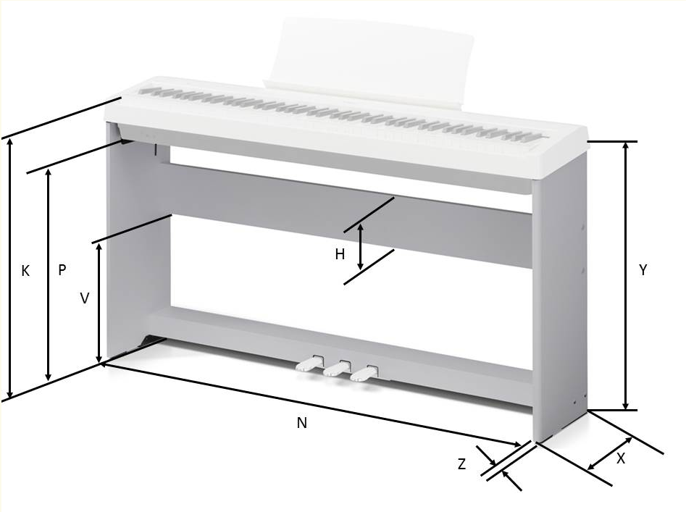

H: 5 1/2 “ ( 13.97 cm)  
N: 49 3/4 “ (126.365 cm)  
X: 10 7/8 “ (27.6225 cm)  
Y:

* The top of side panels slope upwards from 25 3/4 “ (65.405 cm) at front of panel to 26 3/4 “ (67.945cm) at back.
* The ES100 does not sit directly on the side panels. It is screwed into brackets and sits 1/8 “ (0.3175 cm) above the side panels

Z: 3/4 “ (1.905 cm)  
V: 14 1/4 “ (36.195 cm)  
P: 24 “ (60.96 cm)  
K:

* It is about 28 3/16 “ (71.5962 cm) at front straight edge of ES100, before the instruments curved edge starts.
* The top of the ES100 slopes upward front to back, like the side panels.